# Write UMT on a wooden workpiece by using CNC milling machine. Apparatus:

vernier caliper, Wooden workpiece, CNC Milling machine.

# Apparatus:

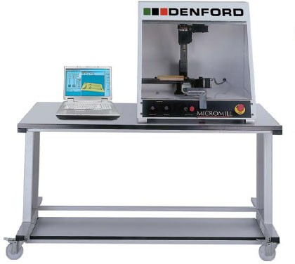

**Final Work piece Geometry**

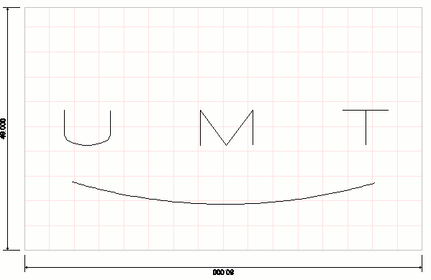

# G and M codes file

G21 G90

(Denford Post Output - QuickCAM 2D Design Ver: 2.1.0.120 *BETA* (Date: 4/27/2016

(Time: 7:04:22 PM

(Source File: C:\Users\Administrator\Desktop\logo.fnc (Web: [www.denford.co.uk](http://www.denford.co.uk/)

(Support: [www.denfordata.com/bb](http://www.denfordata.com/bb) [BILLET X49.000 Y80.000 Z15.000 [EDGEMOVE X0 Y0

G91 G28 X0 Y0 Z0 M05

(Machine: MICROMILL (Material: wood [TOOLDEF T0101 D6.350 M5

G90 M6 T0101 M03 S1500

(Follow. Start Depth:0.000mm Final Depth:2.000mm Tool:1 = 6.350mm Diam. G00 X21.233 Y11.361

G00 Z2.000

G01 Z-2.000 F17.5 G01 X28.233 F80.0 G00 Z2.000

G00 Y6.699

G01 Z-2.000 F17.5 G01 Y16.023 F80.0 G00 Z2.000

G00 X13.814 Y70.431 G01 Z-2.000 F17.5 G17

G3 X13.099 Y11.318 I103.284 J-30.810 F80.0 G01 X13.641 Y9.397

G00 Z2.000

G00 X21.233 Y44.695 G01 Z-2.000 F17.5 G01 X28.233 F80.0 X21.233 Y39.375 X28.233 Y34.041 X21.233

G00 Z2.000

G00 X28.233 Y72.037

G01 Z-2.000 F17.5 G01 X23.228 F80.0 X22.227 Y71.379 X21.562 Y70.049 X21.233 Y68.047 Y66.717

X21.562 Y64.715 X22.227 Y63.371 X23.228 Y62.713 X28.233

G00 Z2.000 G0 Z2.000

G91 G28 X0 Y0 Z0 M05 G90

M30

Which type of operations can perform on CNC Milling machine?

Write the meaning of G01 Z-2.000 F17.5?

What is meaning of G91 G28 X0 Y0 Z0 M05 ?